NAME- Parth Gupta  
Sap Id-500093769  
Course-BBA ABD  
SEMESTER- 4TH SEM

GOOGLE SITE LINK:  
<https://sites.google.com/view/mercedesmaybach/home>

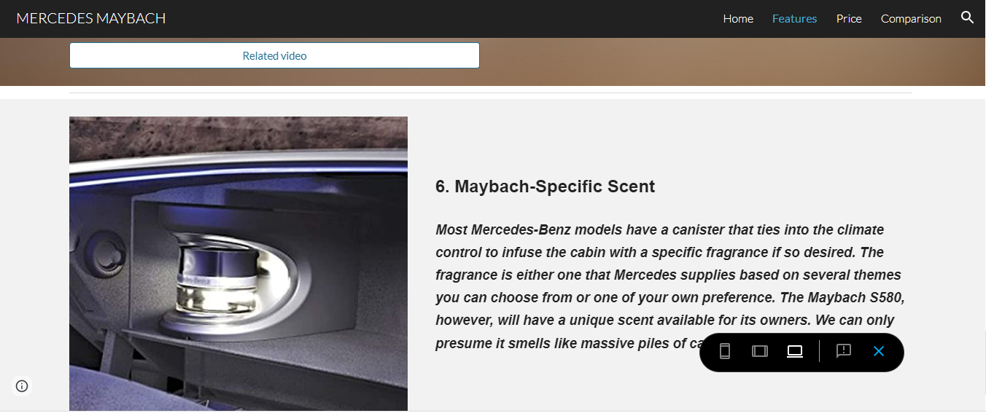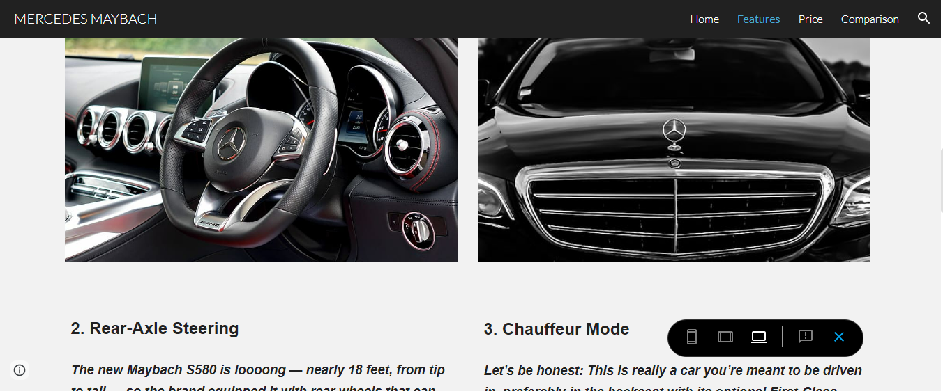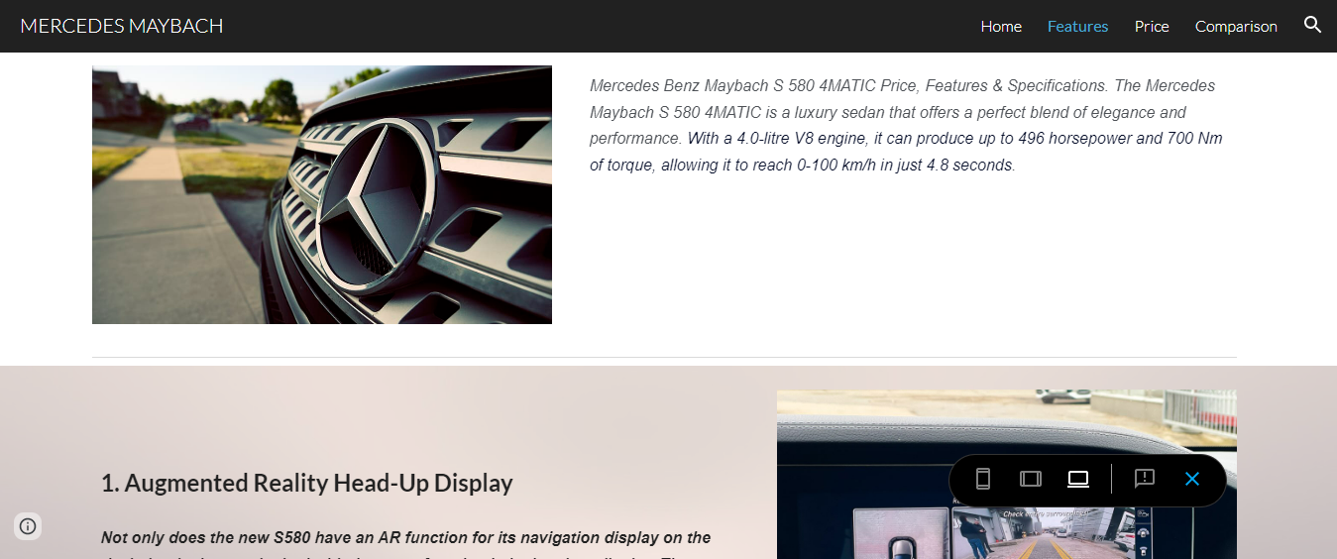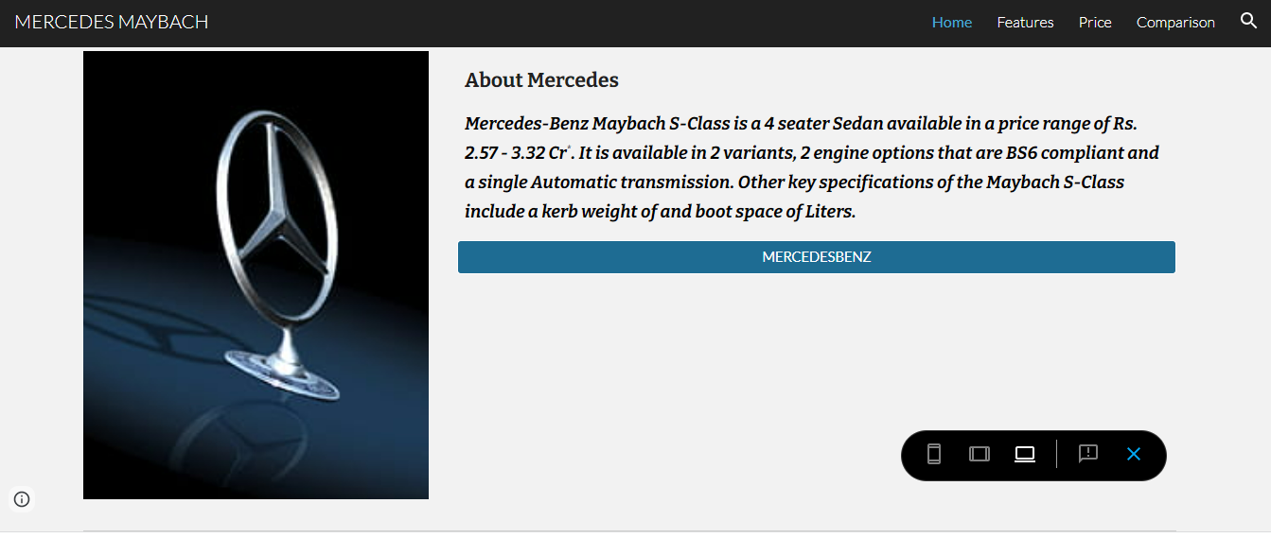

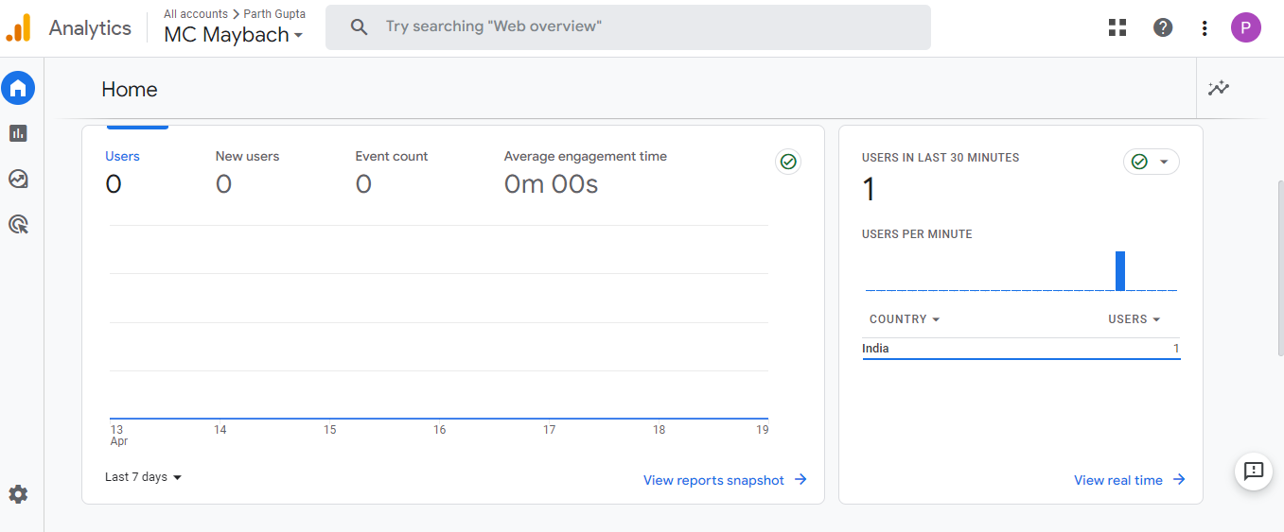

PIC 1-HOME

* What is google analytics?  
  It is a web analytics service that tracks and reports website audiance. It provides website owners with detailed information about their website visitors, including where they are coming from, what pages they visit, how long they stay on the site, and what actions they take on the site.  
  It uses a tracking code that is placed on each page of a website, which collects information about visitors' behavior on the site. The data collected by Google Analytics is used to improve website performance, track the effectiveness of marketing campaigns, and gain insights into customer behavior.
* So here in pic 1, we can see the home page of the google analytics. This shows us the traffic our website is having. Number of users, their engagement time, etc is shown on this page.

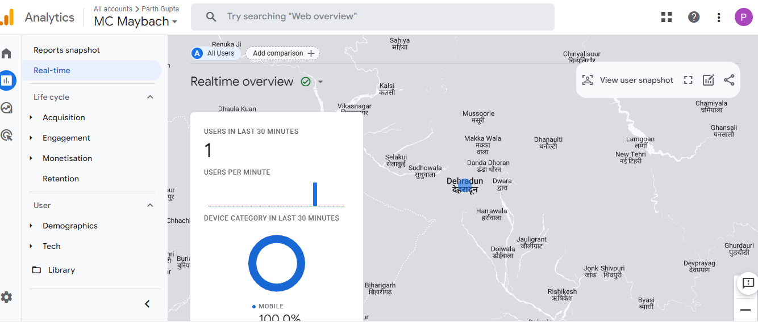  
PIC 2- REAL-TIME OVERVIEW

* So in this pic we can see the real-time overview i.e it tells us what is happening on a website. The real active users and the page they are viewing, sources from where the get the website link or something.
* The real-time overview can be useful for website owners to understand how visitors are interacting with their site in real-time. Overall, the real-time overview provides a information of what is happening on a website at any given moment, giving website owners valuable insights into how their site is performing and how visitors are engaging with their content.

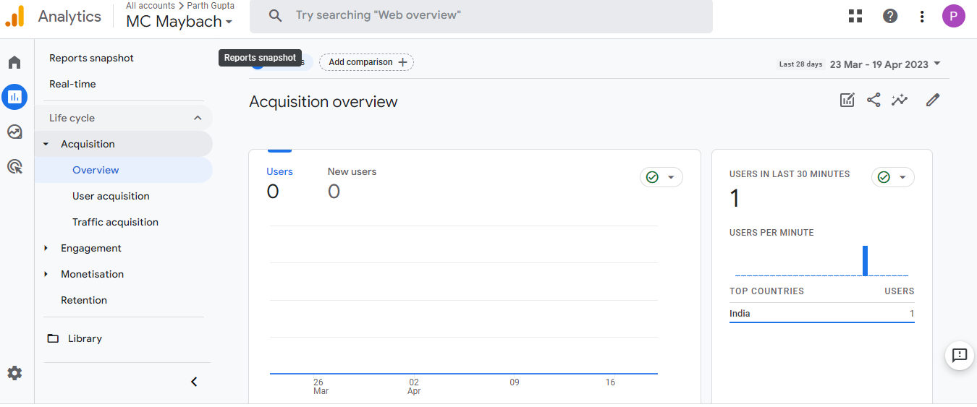

PIC3- ACQUISITION OVERVIEW

* The Acquisition Overview in Google Analytics provides information about how visitors are finding and arriving at a website. It shows website owners the various channels through which visitors are coming to their site, such as organic search, direct traffic, referral traffic, social media, and paid search.
* Overall, the Acquisition Overview provides valuable insights into how visitors are finding a website and can help website owners optimize their marketing efforts for maximum impact.

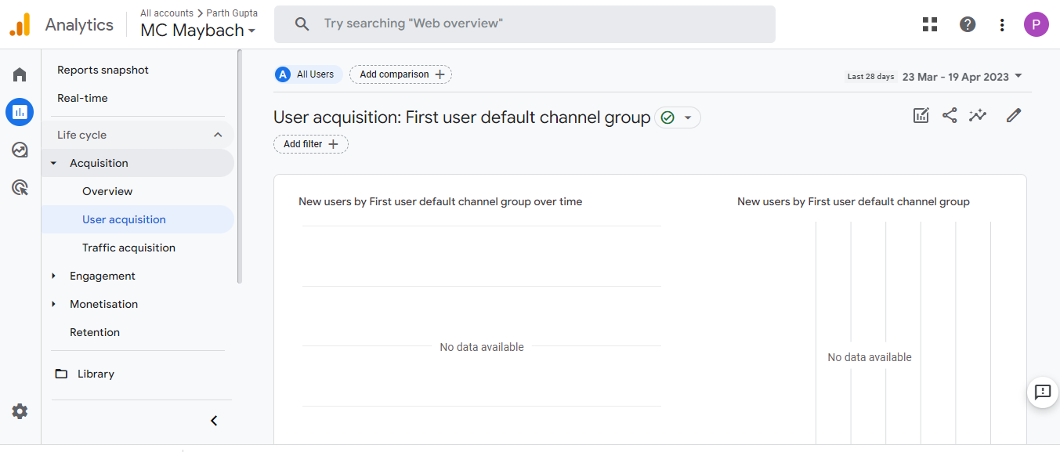

PIC4- ACQUISITION USER ACQUISITION

The Google Analytics acquisition report tells us about the channels or sources from which users are coming to the website. It provides insights into how effectively the website is acquiring users and which channels are generating the most traffic and conversions.

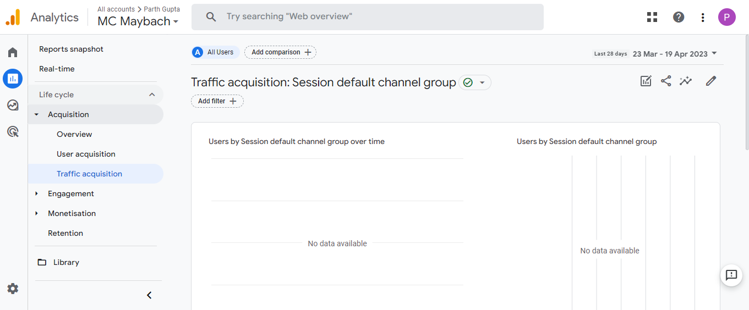

PIC5-TRAFFIC ACQUISITION

* The number of visits and unique visitors: This metric tells us how many times the website has been accessed and how many individual users have visited the site.
* The percentage of new vs. returning visitors: This metric indicates the percentage of users who are visiting the website for the first time, versus those who have visited before.
* The sources of traffic: This metric tells us where users are coming from to access the website, such as organic search, paid search, social media, email, or direct traffic.

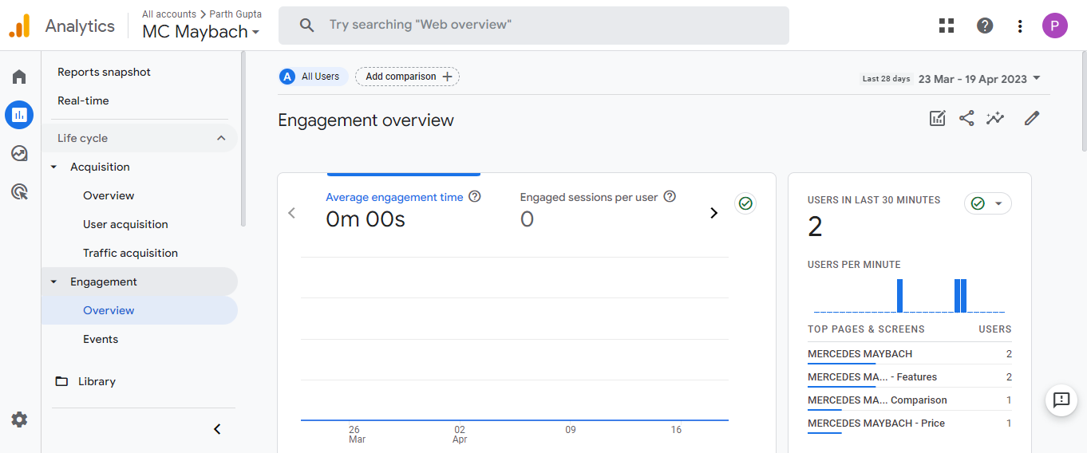

PIC6-ENGAGEMENT OVERVIEW

* The Google Analytics Engagement Overview provides a high-level view of how users are interacting with a website. It shows important metrics related to user engagement, such as the number of page views, the average session duration, the bounce rate, and the percentage of new sessions.

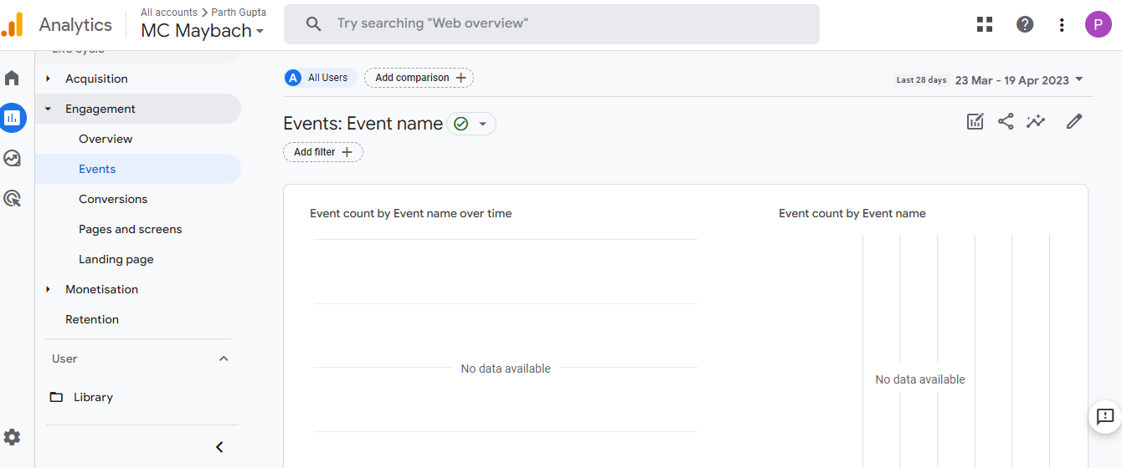

PIC7- ENGAGEMENT EVENTS

* Engagement Events provide detailed information about user interactions with specific elements on a website. An event is any user interaction with content that is tracked separately from a web page load, such as clicking on a button, playing a video, or filling out a form.